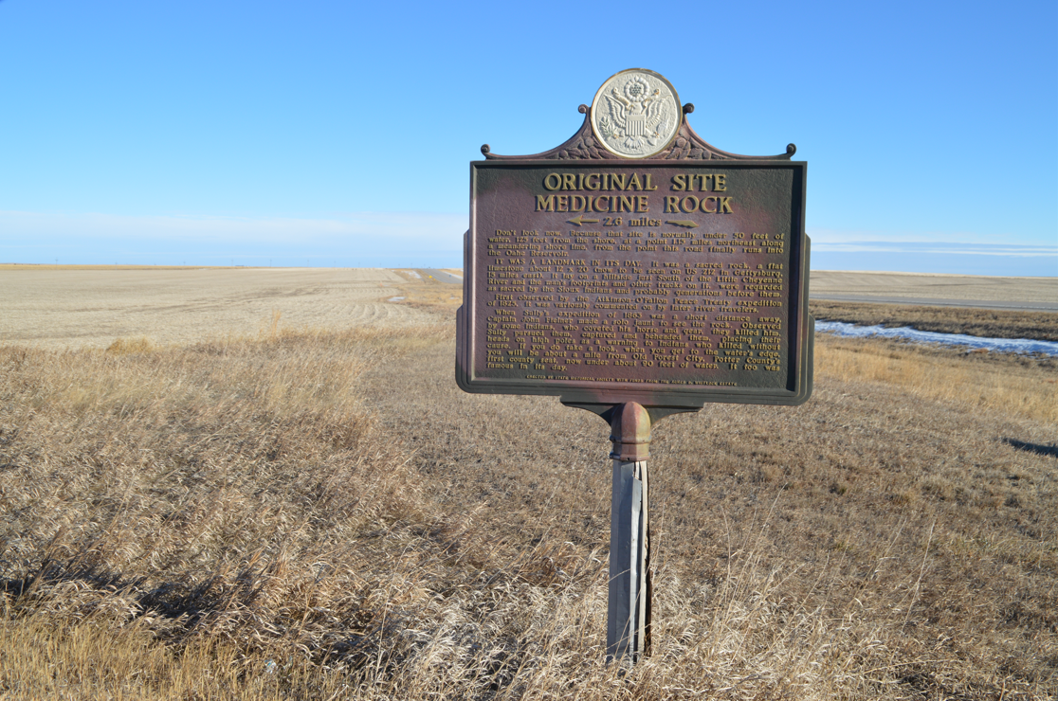

South Dakota Historical Markers
Application and Criteria

Last updated: January 2024

The South Dakota State Historic Preservation Office (SHPO) manages the marker program for the South Dakota State Historical Society. Markers must reflect an accurate and well-rounded historical account of a person(s), place, or event(s). The State Historian may reject an application based on inaccurate, biased, derogatory, or offensive subject material/language.
The South Dakota Department of Transportation (DOT) assists in the installation of markers that are to be placed in the right-of-way of state highways. Installation in other locations is the responsibility of the applicant. The markers come with assembly instructions.
The person or group requesting the marker is responsible for paying for it. The State does not have funding to subsidize marker costs.
How the process works:
- Applications are submitted to SHPO at the address or email included in the application.
- Staff reviews the application and may propose changes/corrections before the marker is approved and the text finalized.
- If proposed to be located in a state highway right-of-way, staff will assist the applicant in filling out the DOT “Application For Permit to Occupy the Right of Way” form. DOT may suggest an alternative location due to safety/liability issues before approving the permit. Existing pull-off locations for maintenance and accessibility may be preferred.
- For markers proposed to be located on federal, county, municipal, or private land, the applicant needs to submit a letter of permission from the property owner or public manager of the public land. This should be included with the application. This does not apply if the applicant is the public official(s) or private landowner requesting the marker.
- After the marker text is approved and placement has been determined, SHPO will forward the final text and details, with your billing address/contact and the delivery address, to Sewah Studios, Inc. (Marietta, Ohio) for manufacturing. If the marker is being installed in a state right-of-way by DOT, the marker should be shipped to the nearest regional DOT shop for installation. The delivery address needs to be “a commercial location with loading access or curb-side service.” See https://sewahstudios.com/shipping-requirements/ for full requirements.
Please allow a minimum of three months from the approval of the application to the delivery of the marker. Sewah Studies requires at least nine weeks for manufacturing and shipping times can vary.
Questions? Email SHPO@state.sd.us or call 605-773-3458 to be directed to the Historic Preservation Specialist for your county.
Application for the South Dakota Historical Marker Program
Return completed application to the South Dakota State Historic Preservation Office, 900 Governors Drive, Pierre, SD, 57501 or email to SHPO@state.sd.us. Questions? Email SHPO@state.sd.us or call 605-773-3458 to be directed to the Historic Preservation Specialist for your county.
Applicant Name/Organization: ____________________________________________________
Contact Name (if different): _______________________________________________________
Contact Phone and/or Email: _____________________________________________________
Proposed title for the historical marker:
The person(s), place, or event(s) to be commemorated:
County the marker is to be placed in: _____________________________________________
What is the proposed location of the marker? Please include digital or hardcopy photographs and/or map of the proposed location.
Examples: 1) Ten miles west of Philip in the right of way of SD HWY 14, 2) Front lawn of Aurora County Courthouse, 3) County Road 56 approximately five miles east of Stickney in a privately owned pasture, 4) In the boulevard of 123 Elm Street in Sioux Falls

What is the relationship of the proposed location to the person(s), place, or event commemorated by the historical marker?
Examples: 1) It is the boyhood home of Peter Norbeck, 2) The Sydney to Deadwood Stage crossed at this point, 3) The first motorcycle track in Sturgis was built on this field

Will the marker be located on a state highway right-of-way? Yes No
If No, owner of proposed marker location: ______
- Letter of permission from federal, county, municipal, or private owner is attached.
Please use a separate sheet of paper to answer the following questions. Number your responses to correspond with the items listed below. Include a bibliography of where you got the information as well as photocopies of book and/or article pages with relevant information. Insufficient research will be returned to the applicant. Please type or print clearly.
- Describe the person(s), place, or event(s) commemorated by the historical marker.
- Explain why the person(s), place, or event(s) is significant to South Dakota history.
- Explain in more detail the relationship between the proposed location and the commemorated person(s), place, or event(s).
- If an image (as etching or metal photo) is proposed to be included on the marker with the text, include a copy and indicate source of the image. If not in the public domain or produced/owned by the applicant, include a copy of the permission to reproduce the image on the marker. The inclusion of an image can affect the pricing.

Attach proposed text of the marker.
Below, select a marker size/type. The estimated word limits are indicated. If continuing text to reverse side (or having different text on reverse), include break point in your proposed text. Using an image on a marker will likely affect the pricing.
Marker pricing from Sewah Studios, effective through December 31st, 2024.
30”H x 42”W marker, same text on both sides:
- 5/8” letter size, max 20 lines, ~230 words per side | $3,070.00
- 1” letter size, max 14 lines, ~117 words per side | $2,770.00
- 1 ½” letter size, max 10 lines, ~58 words per side | $2,710.00
- 2” letter size, max 8 lines, ~36 words per side | $2,610.00
30”H x 42”W marker, different text on reverse side:
- 5/8” letter size, max 20 lines, ~230 words per side | $3,510.00
- 1” letter size, max 14 lines, ~117 words per side | $3,180.00
- 1 ½” letter size, max 10 lines, ~58 words per side | $3,070.00
- 2” letter size, max 8 lines, ~36 words per side | $3,000.00
24”H x 18”W marker, same text on both sides:
- 5/8” letter size, max 15 lines, ~66 words per side | $1,700.00
- 1” letter size, max 11 lines, ~35 words per side | $1,670.00
24”H x 18”W marker, different text on reverse side:
- 5/8” letter size, max 15 lines, ~66 words per side | $1,860.00
- 1” letter size, max 11 lines, ~35 words per side | $1,710.00
Also available from Sewah Studios:
To inquire about refurbishment: https://sewahstudios.com/refurbishment/
To order a replacement post: https://sewahstudios.com/post-order-form/
Refurbish marker only | $1,200.00
Refurbish marker with cap repair | $1,450.00
Replacement 7 ft. post | $375.00
Replacement 10 ft. post | $475.00

